API platform
# Source: Chatgpt (GPT-4-turbo) at [6/24/2025]
An API platform is a comprehensive system that enables the design, development, deployment, management, and monitoring of Application Programming Interfaces (APIs). It acts as a bridge between backend services and client applications, making it easier to expose and consume data securely and efficiently.

🔧 Core Components of an API Platform
# Source: Chatgpt (GPT-4-turbo) at [6/24/2025]
- API Gateway
  - Routes API requests to appropriate services.
  - Handles rate limiting, authentication, logging, etc.
  - Examples: Kong, Amazon API Gateway, Apigee, Azure API Management
- Developer Portal
  - A user interface for developers to discover, test, and subscribe to APIs.
  - Provides documentation, API keys, sandbox environments.
- API Management Tools
  - Track usage, throttle traffic, enforce policies, version APIs.
  - Provides analytics and insights.
- Security Layer
  - Authentication (OAuth 2.0, JWT)
  - Authorization and access control
  - Encryption and threat detection
- API Design Tools
  - Define API contracts using OpenAPI (Swagger), GraphQL, etc.
  - Often support mocking and testing.
- Monitoring & Analytics
  - Tracks performance, uptime, error rates, etc.
  - Example: Datadog, Prometheus, New Relic

🧱 Popular API Platforms
# Source: Chatgpt (GPT-4-turbo) at [6/24/2025]
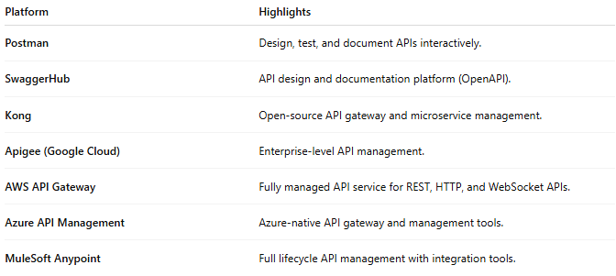

Platform | Highlights
Postman | Design, test, and document APIs interactively.
SwaggerHub | API design and documentation platform (OpenAPI).
Kong | Open-source API gateway and microservice management.
Apigee (Google Cloud) | Enterprise-level API management.
AWS API Gateway | Fully managed API service for REST, HTTP, and WebSocket APIs.
Azure API Management | Azure-native API gateway and management tools.
MuleSoft Anypoint | Full lifecycle API management with integration tools.

⚙️ Use Cases
# Source: Chatgpt (GPT-4-turbo) at [4/24/2025]
- Connecting frontend apps to microservices.
- Public APIs for third-party developers.
- Partner APIs for B2B integrations.
- Internal APIs for modular architecture (microservices).

